Press
Gijón (Spain), January/ 2022
TSK  www.grupotsk.com  grupotsk@grupotsk.com | Parque Científico Tecnológico  C/ Ada Byron 220,33203 Gijón  Asturias, España

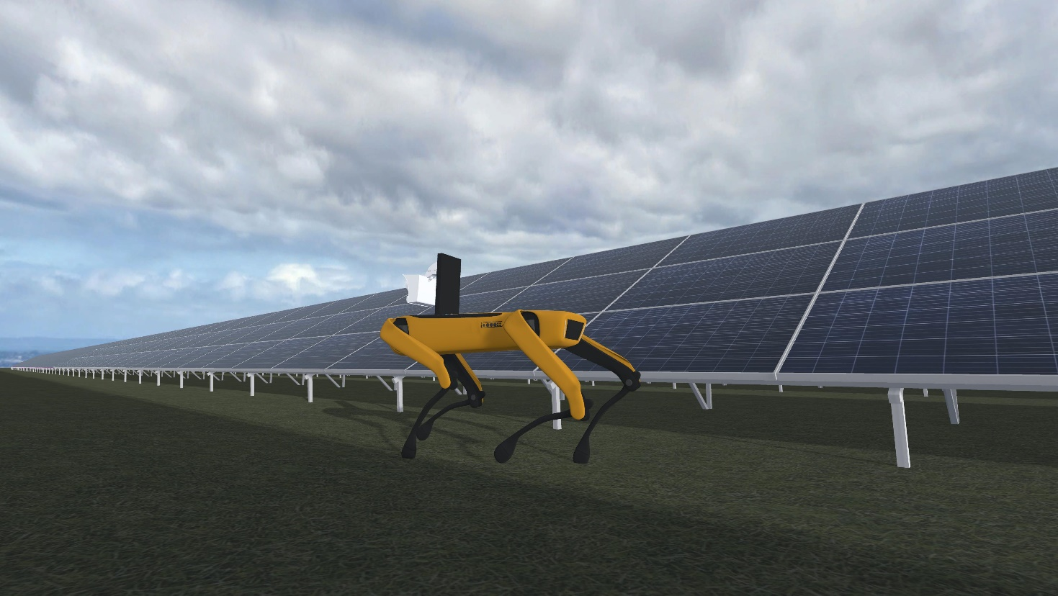

TSK launches two reference projects in energy transformation and digitalisation

Both projects have received funding from the Recovery, Transformation and Resilience Plan (PRTR), which is active in the fields of energy, industry and environment.

Funded through the 2021 "Science and Innovation Missions" programme, the INMERBOT and SOLSTICIA projects are part of the Recovery, Transformation and Resilience Plan and the State Programme to Catalyse Innovation and Business Leadership of the State Plan for Scientific, Technical and Innovation Research 2021-2023. The call is managed through the Centre for the Development of Industrial Technology (CDTI) and its objective is to promote business cooperation R&D projects aligned with one of the nine identified missions. INMERBOT is aligned with the mission "to promote Spanish industry in the industrial revolution of the 21st century" and SOLSTICIA with the mission "to promote information security, privacy and cybersecurity in the Spanish economy and society of the 21st century".

INMERBOT - RESEARCH INTO IMMERSIVE AND SENSORY TECHNOLOGIES FOR COLLABORATIVE INDUSTRIAL ROBOTIC INSPECTION ENVIRONMENTS

This project arises from the existing limitations in efficient human-robot and robot-robot collaboration in inspection and maintenance environments of industrial facilities. The scope of the INMERBOT project is to advance knowledge of teleoperation and management of multi-robot systems in highly immersive environments for inspection and maintenance applications, which involves research into haptic and robotic technologies, analysis of the environment using various sensors, as well as research into the use of artificial intelligence for mobility, defect detection and reconstruction of the environment based on data from sensors and vision cameras.

The consortium of this project is led by TSK with the participation of ALISYS, COTESA, ECAPTURE, ROBOTNIK, APTICA, GPA SEABOTS and SYLTEC. The ITCL and LEITAT technology centres and the Polytechnic University of Madrid and the University of Oviedo are also collaborating.

TSK is mainly participating in the project by researching immersive technologies (virtual, augmented and mixed reality) for remote operation and interaction with multi-robot systems in industrial inspection scenarios. In addition, it will work on the design of new sensors and artificial intelligence algorithms for the detection of events and anomalies.

SOLSTICIA - SOLUTIONS FOR BUILDING CYBER-SAFE AND INTELLIGENT INDUSTRIAL SOFTWARE SYSTEMS BY DESIGN BASED ON ARTIFICIAL INTELLIGENCE TO DRIVE PRODUCTIVITY AND GROWTH IN A CYBER-SECURE ECONOMY AND SOCIETY.

Industry is incorporating many intelligent systems that need to be secured by design if they are not to increase the area of exposure to cyber-attacks. The developers of these intelligent systems are highly competent, but they unconsciously design and develop systems that are prone to vulnerabilities in all domains and use cases, even when operating in tightly controlled development, laboratory and test environments. SOLSTICIA researches to answer the question how can we therefore build intelligent systems to be robust and secure in complex and ambiguous contexts such as those in the industrial domain where the potential consequences of a cyber-attack impact lives or large business losses?

The SOLSTICIA project aims to optimise and secure all intelligent software development processes. During the execution of the project, TSK will work on the Industry 4.0 platform that it has developed over the last few years and on which it has built a catalogue of solutions such as SISREM, SISDRON or SIXPERIENCE. The results of the project will allow the optimisation of the company's intelligent software development process.

This project is led by CAPGEMINI in consortium with TSK, MTP, ATOS, PROXYA, COTESA and THE REUSE COMPANY. The consortium has the collaboration of the Tecnalia technology centre and the Polytechnic University of Madrid.

The approval of these two projects once again certifies TSK's commitment to Innovation, as well as the capacity, maturity and knowledge they have to form part of the transformation of the industry, and therefore help to improve its sustainability, efficiency and digitalisation. Both projects have been promoted by the TSK Digital Innovation division, from which high added value solutions are developed which allow us to improve the value chain of our clients and optimise their performance, based on enabling technologies under the protection of Big Data, Internet of Things, Artificial Vision or Virtual Reality.

TSK is a global company specialising in innovative technologies that contribute to more sustainable development at an international level, providing solutions for different sectors of industry such as electrical infrastructures, industrial plants, power generation plants (conventional or renewable), Gas to Power, water treatment plants or storage and handling facilities for raw materials. TSK currently has sales of close to 1,000 million euros, with more than 1,000 professionals and projects executed in more than 50 countries.
www.grupotsk.com

Contact:
E-mail: press@grupotsk.com
Tel: +34 984 495 548
For more information, please visit: http://www.grupotsk.com

